**PRACTICAL 7**

**Database Management Systems**

|  |  |
| --- | --- |
| **NAME: VARUN KHADAYATE** | **ROLL NO: A016** |
| **PROGRAM: BTECH SY** | **DIVISION: CSBS** |
| **BATCH: 1** | **DATE OF EXPERIMENT: 05/04/2021** |

# AIM

For a given set of relation schemes, create tables and perform the following:

1. Simple Queries, Simple Queries with Aggregate functions, Queries with Aggregate functions (group by and having clause)

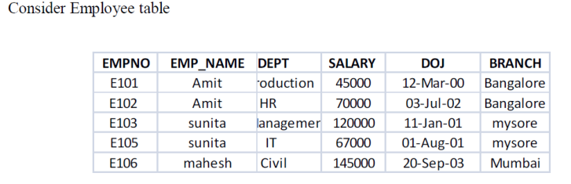

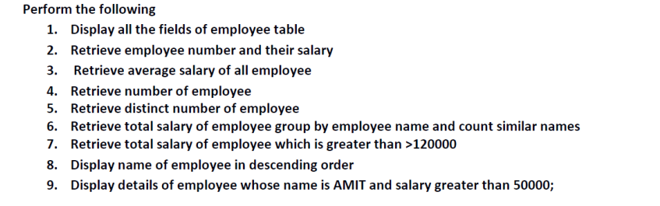

# SNAPHOTS

## Display all the fields of the Employee Table

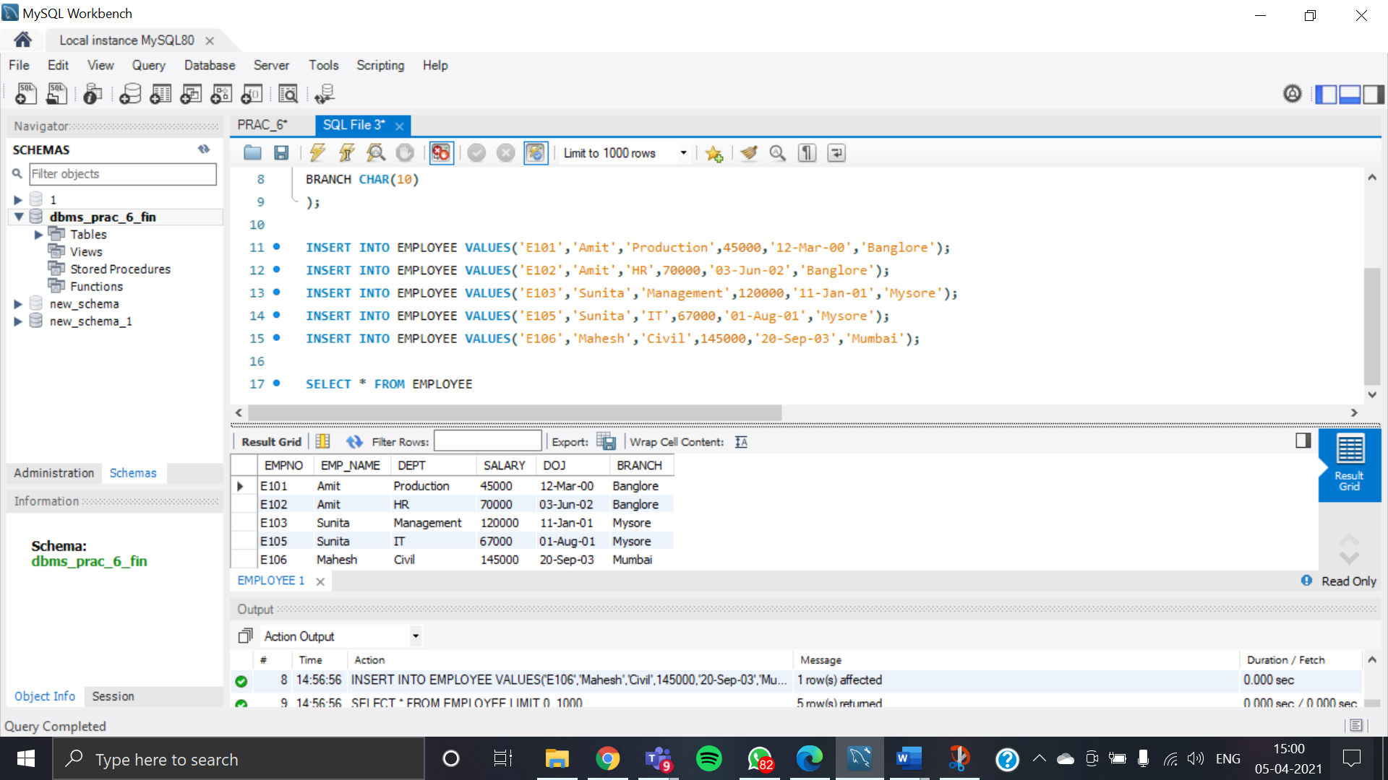

## Retrieve Employee Number and Salary

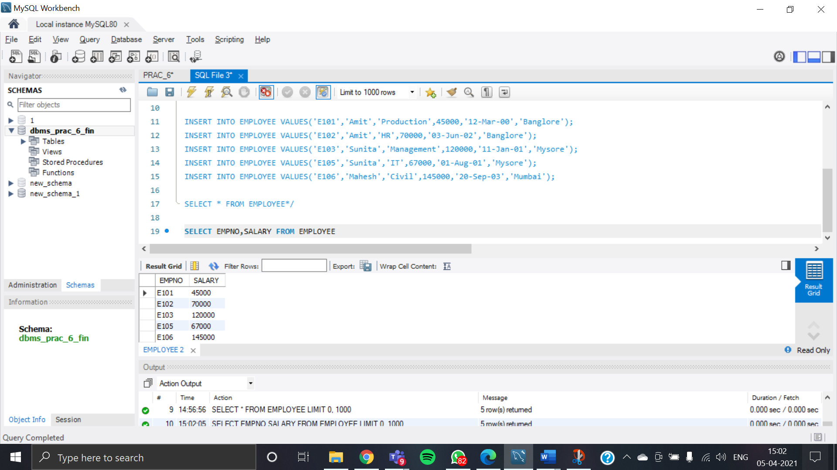

## Retrieve average Salary of all Employee

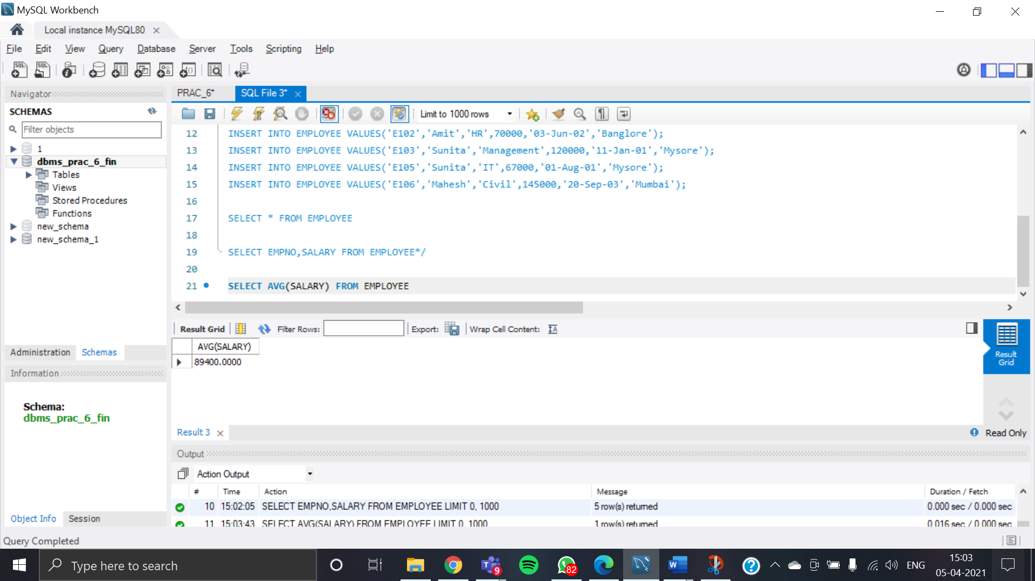

## Retrieve Number of Employees

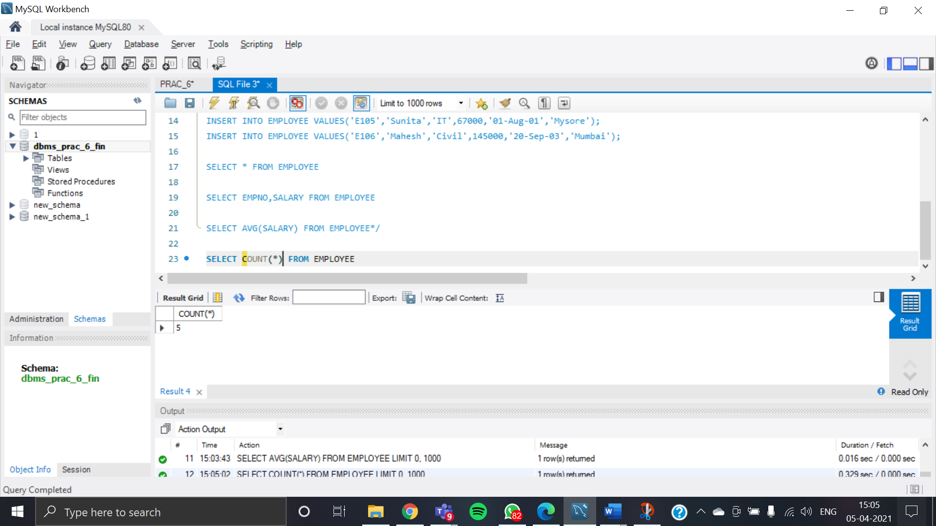

## Retrieve Distinct Number of Employees

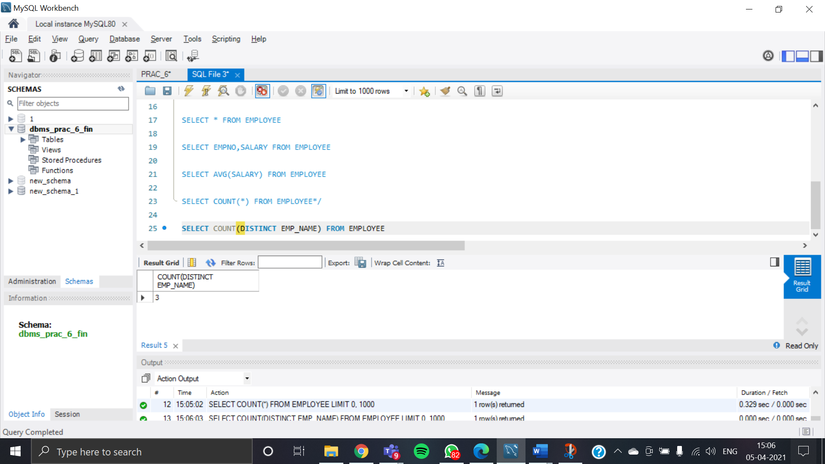

## Retrieve Total Salary of Employees Group by Employee Name and count similar Name

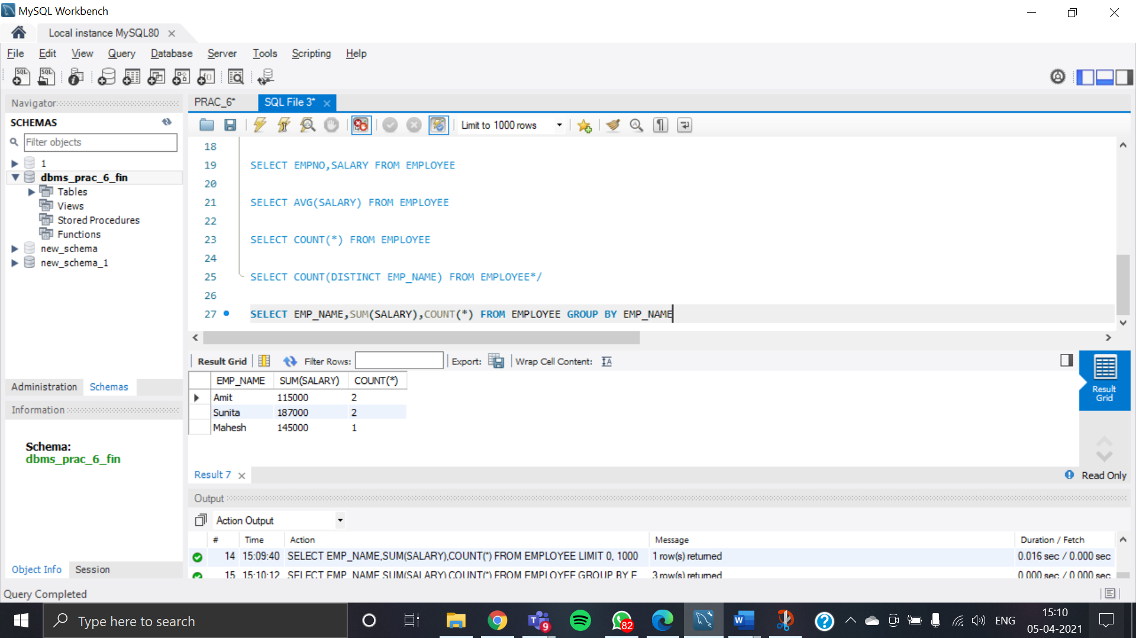

## Retrieve total salary of employee which is greater than 120000

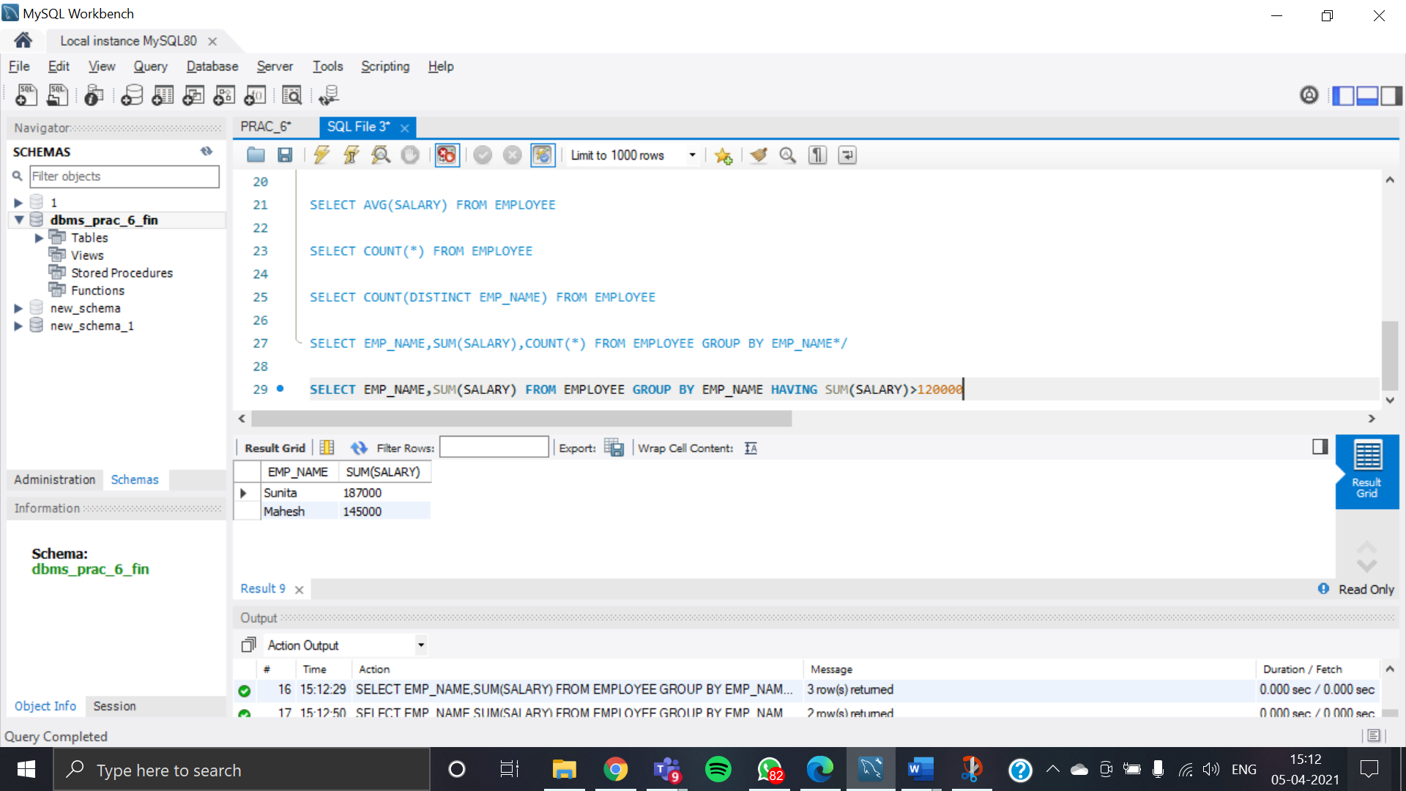

## Display Name of Employee in Descending Order

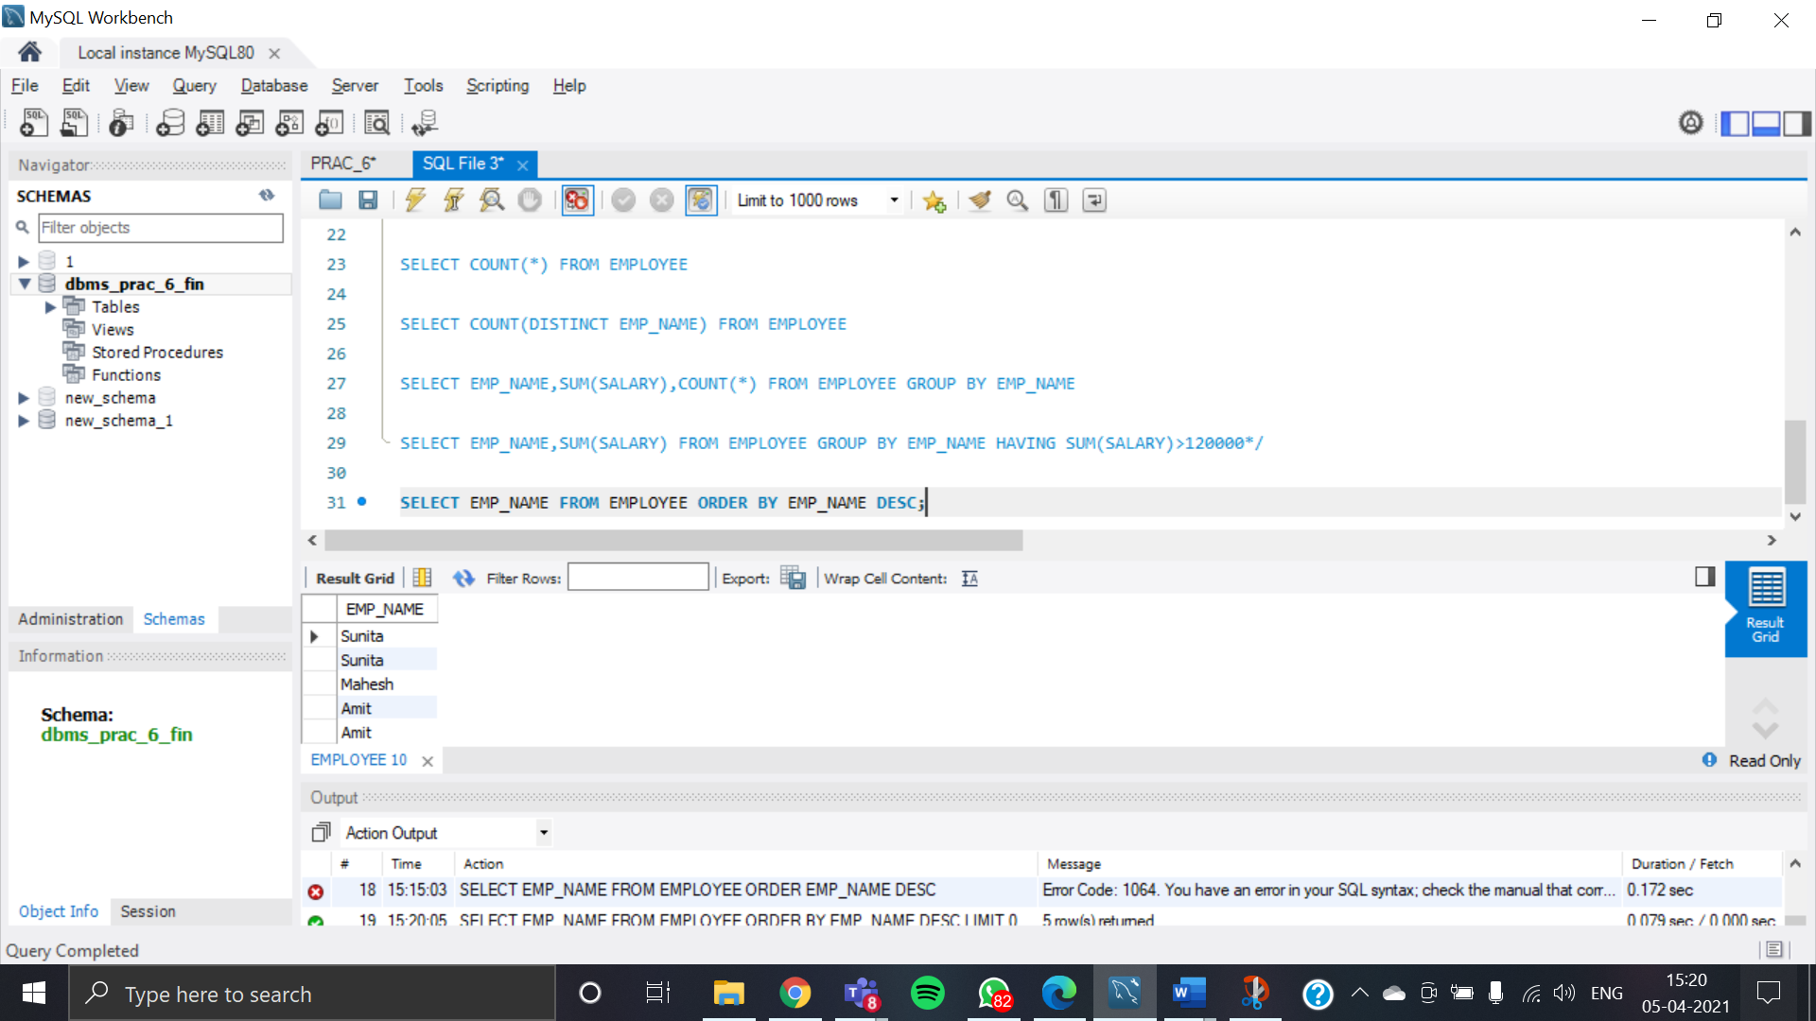

## Display details of Employee whose name is Amit and Salary is greater than 50000

